WW2100 HBV Parameter Calibration

David R. Conklin, Oregon Freshwater Simulations, September 15, 2016

Contents

Scope 2

HBV Parameters in WW2100 2

CFMAX 2

CFR, the refreezing coefficient 3

FC, the field capacity of the topsoil 3

BETA 3

PERC, the percolation fraction 3

UZL 3

K0 4

K1 4

K2 4

Overview of the Calibration Method 4

Observations Used in the Calibration 5

Subareas Used in the Calibration 5

High Cascades Groundwater 8

Operation of PEST 9

Selection of Parameter Values to be used for each IDU 10

Results 12

Discussion 16

Acknowledgments 22

References 22

Figure 1. Nine reservoir drainages used in the first step of the calibration. 5

Figure 2. Subregions colored by HBV parameter set 6

Figure 3. Areas where high Cascades groundwater is added. 9

Figure 4 Location of ecoregions 8, 9, and 10 (in yellow). 11

Figure 5. Areas for which the 2015 valley floor HBV parameters are used (in yellow). 12

Figure 6. Blue River Reservoir inflow rates, 1980-94. 13

Figure 7. Cottage Grove Reservoir inflow rates, 1980-94. 13

Figure 8. Cougar Reservoir inflow rates, 1980-94. . 13

Figure 9. Detroit Reservoir inflow rates, 1980-94. 14

Figure 10. Dorena Reservoir inflow rates, 1980-94. 14

Figure 11. Fall Creek Reservoir inflow rates, 1980-94. 14

Figure 12. Fern Ridge Reservoir inflow rates, 1980-94. 15

Figure 13. Green Peter Reservoir inflow rates, 1980-94 15

Figure 14. Hills Creek Reservoir inflow rates, 1980-94. 15

Figure 15 Blue River reservoir pool elevations, Ref scenario 2010-99. 17

Figure 16 Cottage Grove reservoir pool elevations, Ref scenario 2010-99. 18

Figure 17. Cougar reservoir pool elevations, Ref scenario 2010-99 18

Figure 18. Detroit reservoir pool elevations, Ref scenario 2010-99 19

Figure 19. Dorena reservoir pool elevations, Ref scenario 2010-99 19

Figure 20. Fall Creek reservoir pool elevations, Ref scenario 2010-99. 20

Figure 21. Fern Ridge reservoir pool elevations, Ref scenario 2010-99. 20

Figure 22. Green Peter reservoir pool elevations, Ref scenario 2010-99. 21

Figure 23. Hills Creek reservoir pool elevations, Ref scenario 2010-99. 21

Table 1. Reservoir drainages targeted for recalibration. 6

Table 2. Final HBV parameter values. 7

Table 3. High Cascades groundwater 8

Table 4 PEST operation 10

# Scope

This document describes how the WW2100 HBV parameter values were determined in the spring and summer of 2016.

# HBV Parameters in WW2100

The WW2100 model includes a version of the HBV runoff model (Seibert 1997) as a submodel. WW2100-HBV is an adaptation of the HBV model to the WW2100 modeling framework in general and to the WW2100 Flow plugin in particular. Many of the parameters in the standard HBV model appear also in WW2100-HBV, but not all. Those that do appear in the WW2100-HBV model, and for which good values were sought during the 2016 calibration work, are described below. There are 9 in all. One of these parameters (FC) is also used in WW2100’s evapotranspiration submodel, EvapTrans.

## CFMAX

CFMAX is the amount of snow, measured as mm of SWE, which will melt per day per deg C above 0 C.

## CFR, the refreezing coefficient

When the temperature is below the snow threshold, some water in the snowpack may refreeze. The amount of water which could refreeze, in mm, is CFR*CFMAX per day per deg C below the snow threshold.

## FC, the field capacity of the topsoil

In HBV, FC is used in calculating the groundwater recharge fraction, which is the fraction of the incoming rain and snowmelt which bypasses the topsoil and goes directly to the subsoil. The groundwater recharge fraction is calculated as the amount of water currently in the topsoil (to be exact, the amount above 10 mm, taken as the wilting point), expressed as a fraction of FC, raised to the power BETA. When the topsoil is already at field capacity, all the incoming water bypasses the topsoil and recharges the subsoil.

In WW2100’s evapotranspiration submodel, FC is used in the calculation of the soil water threshold at which transpiration begins to shut down due to lack of soil water. The threshold is calculated as

0.5*(FC - 10 mm).

## BETA

BETA is used to calculate the groundwater recharge fraction. See the description under FC above

## PERC, the percolation fraction

PERC is the fraction of the water in the subsoil pool which percolates down to the groundwater pool each day.

## UZL

UZL is a soil water threshold value in mm which is used in the decision about which of two forms of the q0 calculation to use. q0 is the amount of water that flows from the subsoil to the stream each day. When the water content of the subsoil is above UZL, q0 is calculated as

K0*(subsoil water content - UZL) + K1*subsoil water content

When the water in the subsoil is at or below UZL, q0 is just

K1*subsoil water content

Note that sets of PERC, UZL, K0, and K1, which result in more water flowing out of the subsoil pool than there is in the pool to start with, are non-physical. The Q0() procedure returns a value which is never more than the amount that was in subsoil at the beginning of the day. When the percolation amount plus q0 exceed the starting amount in the subsoil plus the groundwater recharge, the percolation amount is reduced accordingly, i.e. water flows to the stream before it percolates downwards.

## K0

K0 is dimensionless, and is used in the calculation of q0, the water which flows from the subsoil to the stream. See the description under UZL.

## K1

K1 is dimensionless, and is used in the calculation of q0, the water which flows from the subsoil to the stream. See the description under UZL.

## K2

K2 is dimensionless, and is the fraction of the groundwater pool which flows to the stream each day.

# Overview of the Calibration Method

We used the Parameter Estimation Program, PEST (www.pesthomepage.org), to identify sets of the 9 parameter values which produce good correlations between streamflows simulated by WW2100-HBV and stream gage readings supplied by the USGS. We divided our study area, the Willamette River Basin (WRB), into a number of drainages for calibration purposes, ultimately using 14 different sets of parameter values in different parts of the WRB. Thirteen of the parameter sets were produced by Oregon Freshwater Simulations in 2016; one parameter set was taken from calibration work by Eric Watson and Yeejun Chang at Portland State University in 2015. Our use of PEST was an adaptation and refinement of the methods used by Watson and Chang.

PEST works by selecting a set of parameter values, running the WW2100 model, and calculating a value representing the divergence of the simulation results from the gage readings. This process is repeated with different sets of parameter values in a systematic exploration of the parameter space. The process terminates when successive adjustments to the parameter values fail to reduce the divergence by a specified amount. The model may exhibit equifinality: different sets of parameter values may produce equally good simulation results.

The target HBV parameters characterize the average soil drainage and snow melt behavior of a basin, properties which may be measurable at a point but are not directly observable for the basin as a whole. Soil drainage and snow melt properties as basin averages vary from basin to basin as a result of differences in soil composition and depth, bedrock characteristics, vegetative cover, topography, and other factors. Accurate simulation of the inflows to the WRB reservoirs is important to the success of the WW2100 model as a whole, so we identified 9 reservoir drainages to be individually calibrated using PEST as the first step in our process. Parameter values for the remaining parts of the WRB were selected using a variety of methods in subsequent steps.

# Observations Used in the Calibration

Stream gage readings are the result not only of natural drainage properties but also of upstream diversions, as for irrigation and municipal use, and of any upstream reservoir operations. The USGS has published both actual gage readings and also synthetic gage readings which estimate streamflows in the absence of anthropogenic effects. The synthetic readings are referred to as “NRNI” data, short for “no reservoirs no irrigation”. NRNI data is available for only a subset of the USGS gage locations in the WRB. We calibrated to NRNI data where available, and also in some cases to actual gage readings where NRNI data was not available.

# Subareas Used in the Calibration

The nine reservoir drainages used in the first step of our 2016 calibration are shown in Figure 1 and their characteristics are listed in Table 1. Reservoir drainages targeted for recalibration.

PEST calibrations were performed on the nine reservoirs plus an additional 5 areas; all fourteen areas are shown in Figure 2. Subregions colored by HBV parameter set The HBV parameter sets obtained from the PEST calibrations are given in Table 2. HBVCALIB is an index to the different sets of HBV parameter values and the subareas where they are used, stored as an IDU attribute.

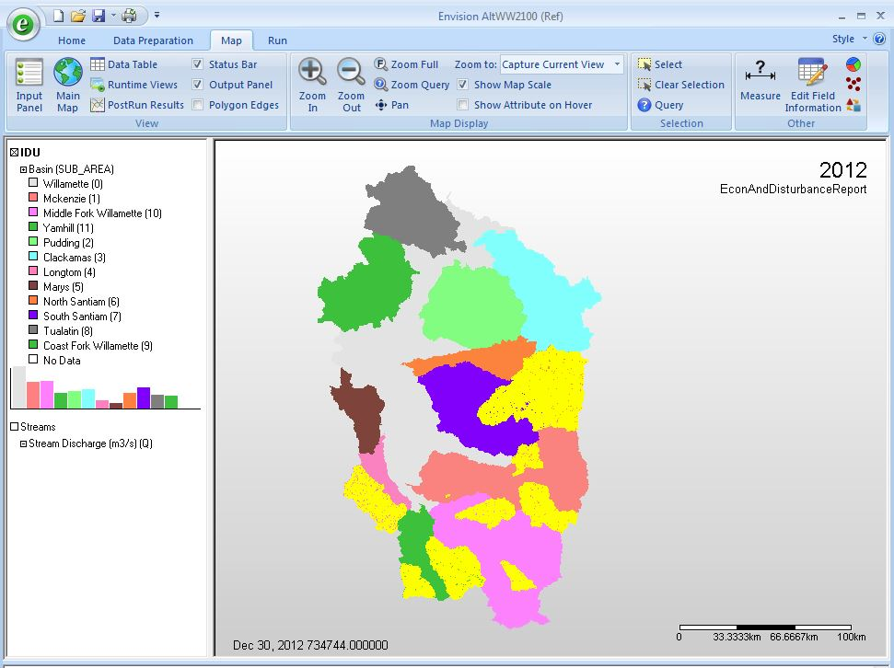

Figure . Nine reservoir drainages used in the first step of the calibration.

Table . Reservoir drainages targeted for recalibration.

|  |  |  |  |
| --- | --- | --- | --- |
| **Tributary** | **Reservoir** | **HBVCALIB** | **area (ac)** |
| Coast Fork | Cottage Grove | 6 | 67234 |
| Coast Fork | Dorena | 5 | 169344 |
| Long Tom | Fern Ridge | 7 | 159533 |
| McKenzie | Blue River | 9 | 55977 |
| McKenzie | Cougar | 8 | 132250 |
| Middle Fork | Fall Creek | 4 | 120784 |
| Middle Fork | Hills Creek | 1 | 247923 |
| N. Santiam | Detroit | 12 | 278017 |
| S. Santiam | Green Peter | 10 | 211970 |

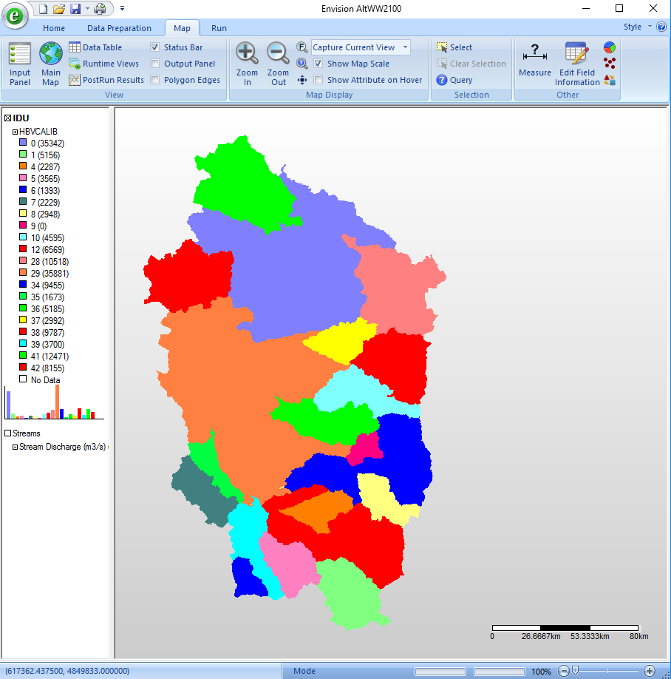

Figure . Subregions colored by HBV parameter set

Table . Final HBV parameter values.

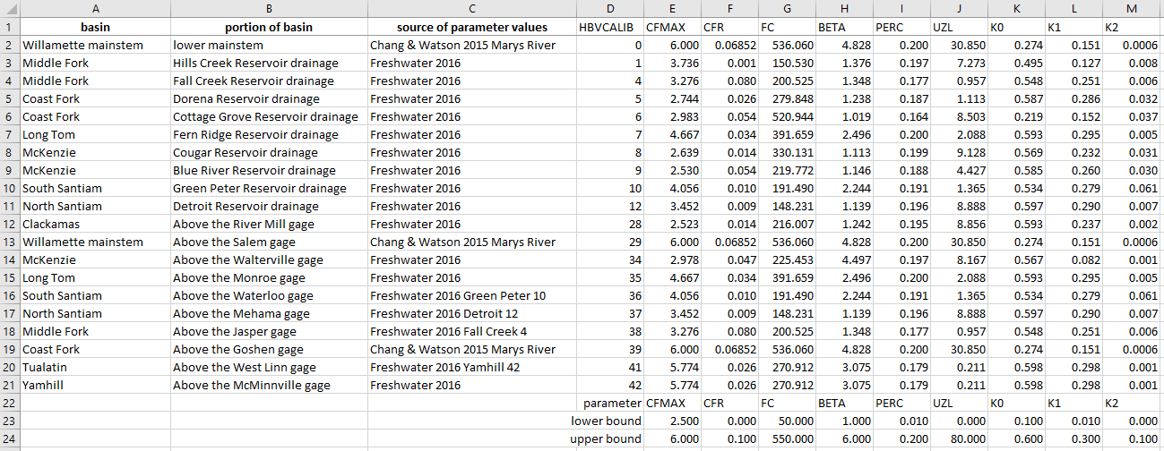

# High Cascades Groundwater

In the high Cascades along the eastern side of the WRB, groundwater moves along paths which cross the boundaries between drainages. In some basins, a significant fraction of the streamflow comes from precipitation which fell outside the basin or in prior years. In such areas, we model High Cascades groundwater as a daily addition to every stream reach, constant over all 365 days per year and constant over all the reaches in the area.

Table 3 gives the amounts of groundwater additions by area. 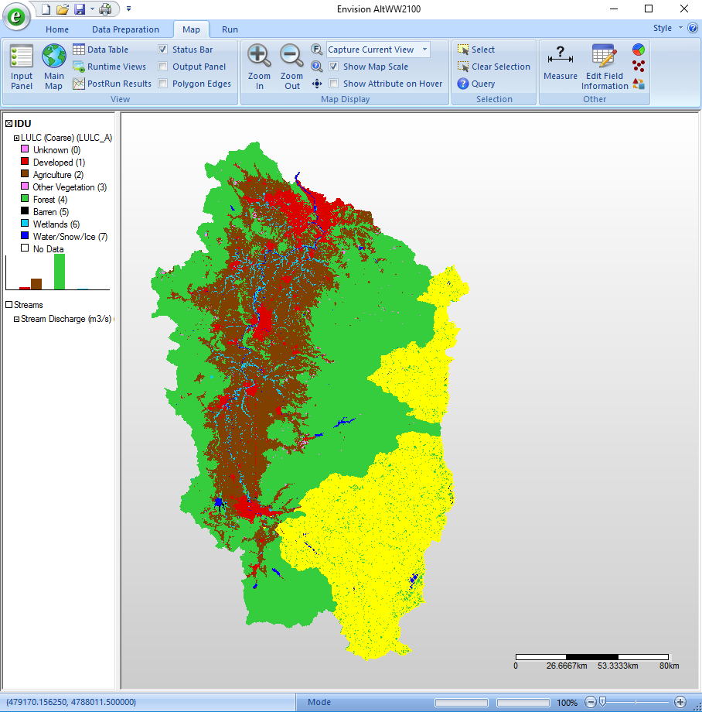

Figure 3. Areas where high Cascades groundwater is added.

shows where the groundwater is added. The amounts of groundwater to add were determined in consultation with Sarah Lewis at Oregon State University and Gordon Grant in the USDA Forest Service.

Table . High Cascades groundwater

|  |  |  |
| --- | --- | --- |
| Area | HBVCALIB or other spec | cms |
| McKenzie basin above Walterville | 8, 9, 34 | 34.7 |
| upper Clackamas basin | SUB_AREA=3 and  (Ecoregion=9 or Ecoregion=10) | 16.4 |
| N Santiam, Detroit reservoir drainage | 12 | 11.6 |
| Middlefork basin above Jasper | 1, 4, 38 | 12.2 |
| total for WRB |  | 74.9 |



Figure . Areas where high Cascades groundwater is added.

# Operation of PEST

The protocol which we used for running PEST in 2016 was a refinement of the one used by Watson and Chang in 2015. We used PEST’s Shuffled Complex Evolution option (the sceua_p command), with these inputs

Initial number of complexes: 4

Minimum number of complexes: 4

Parameter sets in each complex: 15

Parameter sets per sub-complex: 8

Evolution steps before shuffling: 8

and default values for the remaining inputs.

We used the 15-year period 1980-1994 as our reference period. Daily gage or NRNI readings from those years were compared with daily simulated streamflows for the same period. The WW2100 model was driven by daily meteorological data from the MACA training data set. The objective function was calculated as the sum of the squares of the daily differences between the gage readings and the simulated streamflows at the outlet of the target drainage.

Target gage data had some missing days and some non-physical negative values; those values were ignored when calculating the objective function. The use of squared differences in the objective function gives outliers disproportionate influence; some outliers were removed from the target gage data by hand. (Strictly speaking, the effect of squaring the differences depends on whether the magnitude of the differences is greater than or less than one; outlier differences in our data are generally greater than one.)

Table 2 gives some details of the PEST runs. The degree of reduction in the objective function value from initial to final depends on how good the initial set of parameter values is. Our initial values were generally informed by the earlier Watson-Chang calibration. We achieved an average objective function reduction of 13% for the 13 drainages on which we ran PEST in 2016. Reductions in individual drainages ranged from 2% to 33%.

Data used in and produced by the PEST runs in 2016 is archived in the WW2100svn Subversion repository (<https://freshwater.ceoas.oregonstate.edu:8443/svn/WW2100svn>) at Envision/StudyAreas/HBVCALIB. The repository is publicly accessible for reading using “guest” as your username and a null string for the password.

Table PEST operation

|  |  |  |  |  |  |  |
| --- | --- | --- | --- | --- | --- | --- |
|  | HBVCALIB | # of WW2100 executions | # of PEST cycles | final objective fcn value | initial objective fcn value | elapsed time |
| Hills Creek Reservoir drainage | 1 | 553 | 13 | 3360000 | 4060000 |  |
| Fall Creek Reservoir drainage | 4 | 335 | 7 | 2330000 | 2620000 |  |
| Dorena Reservoir drainage | 5 | 491 | 13 | 2861789 | 3164780 | 6 days |
| Cottage Grove Reservoir drainage | 6 | 245 | 6 | 344478 | 354746 |  |
| Fern Ridge Reservoir drainage | 7 | 578 | 14 | 1322233 | 1694786 | 7 days |
| Cougar Reservoir drainage | 8 | 449 | 10 | 1800000 | 1903340 |  |
| Blue River Reservoir drainage | 9 | 494 | 11 | 1338436 | 1410000 |  |
| Green Peter Reservoir drainage | 10 | 294 | 6 | 63600000 | 65100000 |  |
| Detroit reservoir drainage | 12 | 713 | 17 | 9280000 | 11710670 | 15 days |
| Clackamas above River Mill | 28 | 845 | 18 | 15913370 | 19100000 | > 1 week |
| McKenzie above Walterville | 34 | 579 | 13 | 25508260 | 29431490 | 6 days |
| Long Tom above Monroe | 35 | 445 | 12 | 27989470 | 30576770 | 4-5 days |
| S. Yamhill above McMinnville | 42 | 700 | 16 | 11200000 | 16800000 |  |
| Marys River |  |  |  |  |  |  |

# Selection of Parameter Values to be used for each IDU

NRNI synthetic flow data was limited at locations other than the reservoir outlets. We were able to do PEST calibrations for 3 additional areas - the Long Tom basin above the gage in Monroe, the McKenzie basin above the gage in Walterville, and the Clackamas basin above the gage at River Mill.

For most IDUs within the drainages which we had explicitly calibrated, we used the parameter values determined by the calibration. We made an exception for the snowy parts of the basin, which we took as those in ecoregions 8, 9, and 10. In those ecoregions, we used the parameter values obtained for the Clackamas above River Mill, our highest elevation calibrated area. Figure 4 shows the location of those ecoregions in the Willamette River Basin.

For all the IDUs not in an explicitly calibrated basin and not in those 3 ecoregions, we used the HBV parameter values for the valley floor from the 2015 Watson and Chang calibration. Figure 5 shows the area in which the valley floor calibration was applied.

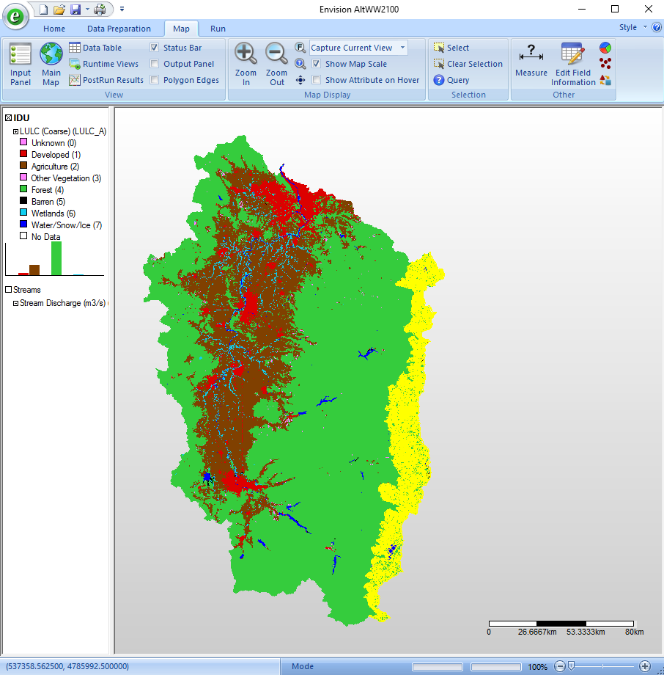

Figure Location of ecoregions 8, 9, and 10 (in yellow).

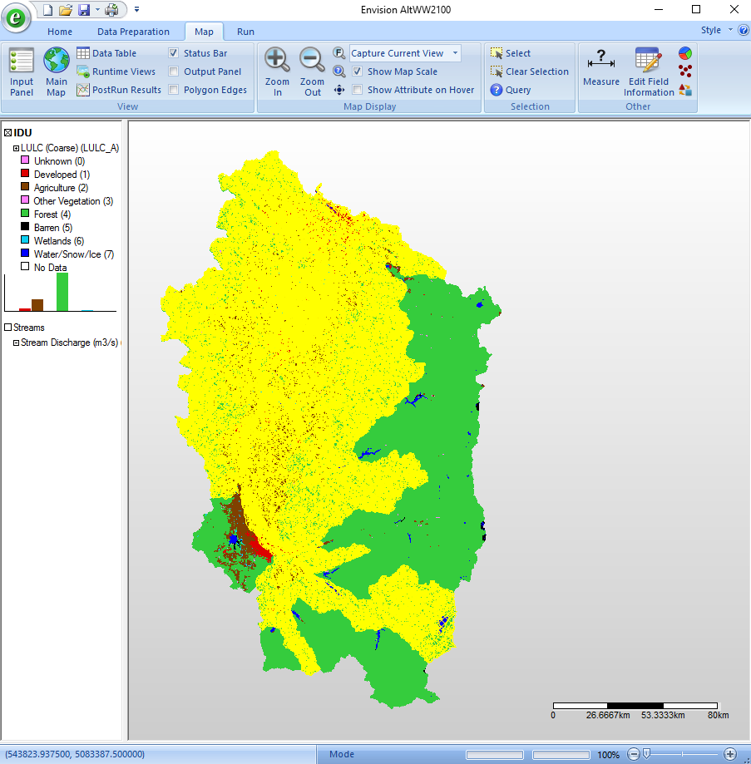

Figure . Areas for which the 2015 valley floor HBV parameters are used (in yellow).

# Results

Table 2 and Figure 2 present the final values chosen for the HBV parameters and where they apply.

Beginning with Figure 6 there is a series of 9 figures showing the observed and simulated annual inflows for the 9 reservoir drainages targeted in the first step of our calibration process. In this series of figures, “WW2100 2.3” uses the 2015 calibration; “new calib” uses the 2016 calibration; “obs” or “observed” is the NRNI data. With a few single-year exceptions, the calibrated simulations are capturing both the amounts and year-to-year variability of annual inflows reasonably well, in the years used for the calibration itself.

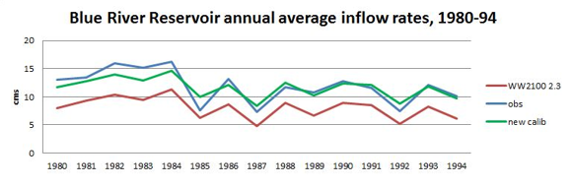

Figure . Blue River Reservoir inflow rates, 1980-94.

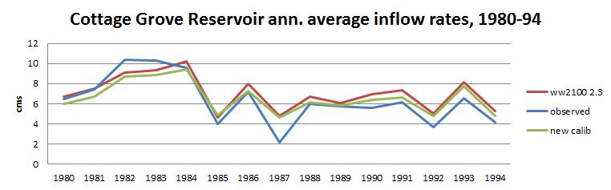

Figure . Cottage Grove Reservoir inflow rates, 1980-94.

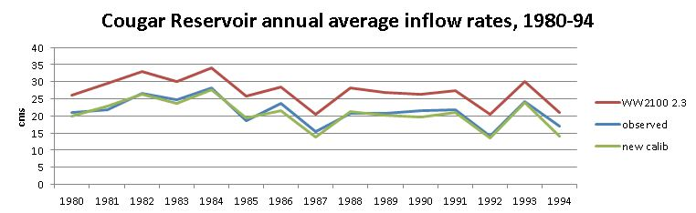

Figure . Cougar Reservoir inflow rates, 1980-94. .

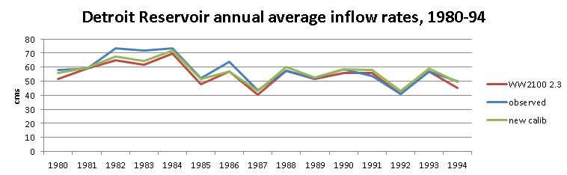

Figure . Detroit Reservoir inflow rates, 1980-94.

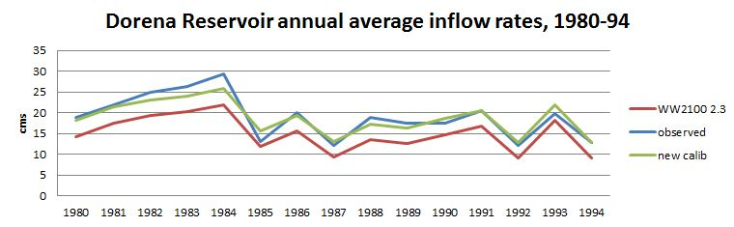

Figure . Dorena Reservoir inflow rates, 1980-94.

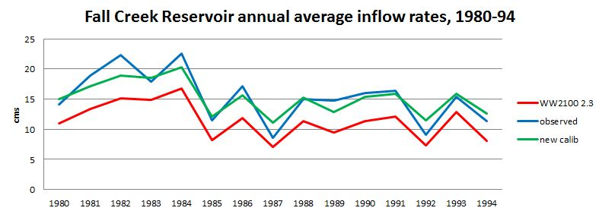

Figure . Fall Creek Reservoir inflow rates, 1980-94.

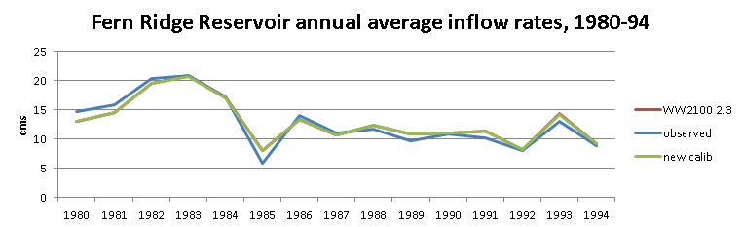

Figure . Fern Ridge Reservoir inflow rates, 1980-94.

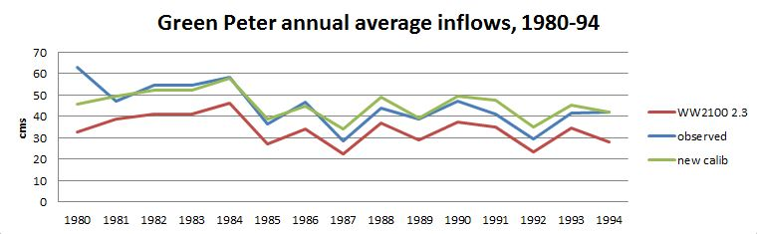

Figure . Green Peter Reservoir inflow rates, 1980-94

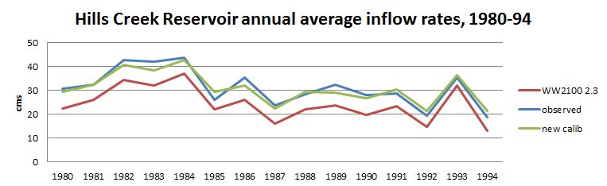

Figure . Hills Creek Reservoir inflow rates, 1980-94.

# Discussion

This is not a perfect calibration. We began the calibration process with some naiveté about PEST, HBV, and even the WW2100 model itself. Over the course of the work we corrected some of our early mistakes, but not all of them. Nevertheless, the WW2100 model as calibrated does an effective job of reproducing the magnitude, interannual variability, and daily variability of streamflows for the 1980-94 calibration period and also for the years 1995-2009.

We reduced the number of HBV parameters to be calibrated from 14 in the 2015 calibration to 9. Our choice of which HBV parameters to calibrate could have been improved further by omitting CFR, the refreezing coefficient. For our region’s climate, characterized by mostly above-freezing or near-freezing temperatures, CFR has little effect on the simulation results. Fixing the value of CFR at 0.05, as suggested in personal communications from Kellie Vache and Anne Nolin, would have speeded up the PEST runs by reducing the number of parameters from 9 to 8.

We retained the form of the objective function which had been used in the 2015 calibration, the sum of the squared daily differences. With the characteristic magnitudes in our data, this form gives undue weight to outliers. If we were to repeat this work, we would try using the sum of the absolute values of the differences as the objective function. A further refinement, which would allow comparison of objective function values between basins, would be to divide by the long term average daily flow for the basin being calibrated.

We did improve on the 2015 calibration by more carefully constraining the parameter values to ranges which made sense mathematically and which were consistent with published reports. The bounds that we used for the parameter values are shown at the bottom of Table 2. After setting the ranges, however, we relied entirely on PEST to find the parameter values. If we had been able to spend more time on the calibration, we would have looked at when and where the largest differences between simulated streamflows and gage readings occur, with an eye to identifying HBV mechanisms which might be improved manually.

The 2015 calibration made use of gage readings from about 18 small basins, chosen to avoid anthropogenic effects. The final parameter values from that calibration consisted of 4 sets, which were applied in 4 different groups of ecoregions (High Cascades, western Cascades, valley floor, and Coast Range). The specific parameter values in the 4 sets were averages of the parameter values produced by PEST for the smaller basins. Exact details of the averaging process are unknown to us.

Our use of PEST in 2016 produced 13 sets of parameter values. We applied those sets directly to different parts of the WRB, without averaging. We also chose to use one of the PEST-produced sets from 2015 as representative of soil and climate conditions on the valley floor, below the elevations of the gages we used. Figure 2 shows how we applied our sets of parameter values across the basin.

A criticism had been made of the WW2100 simulation results using the 2015 calibration, that the reservoirs failed to refill more often in the simulations than would be expected from the historical record. Accordingly, one of the objectives of our calibration in 2016 was to improve the simulation of reservoir refills in spring. That objective led to the decision to use PEST on reservoir drainages rather than on the smaller basins used in the previous calibration. Reservoir refill patterns in the Reference scenario simulations of the 2010-99 years are materially different using the 2016 calibration for most of the 9 reservoirs; see the series of figures beginning with Figure 15. In these figures the x-axis is days since December 31, 2009. The blue line traces the seasonal changes in the reservoir level; the red line behind the blue line is the rule curve elevation. Where the annual peak is red, the reservoir has failed to refill.

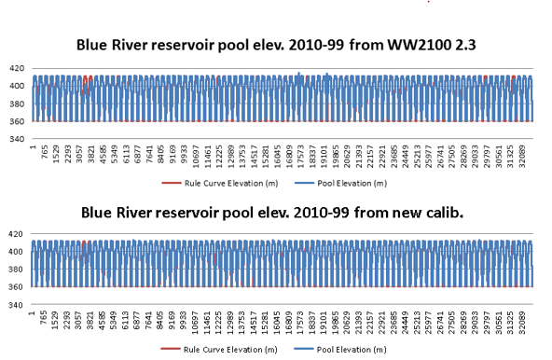

Figure Blue River reservoir pool elevations, Ref scenario 2010-99.

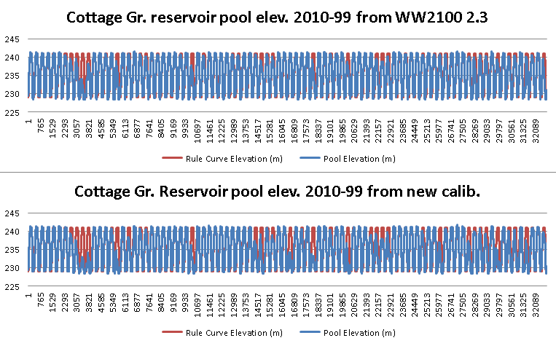

Figure Cottage Grove reservoir pool elevations, Ref scenario 2010-99.

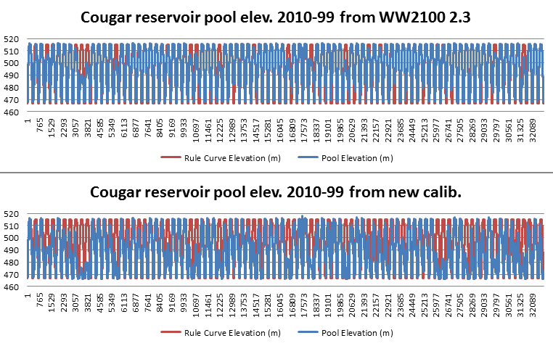

Figure . Cougar reservoir pool elevations, Ref scenario 2010-99

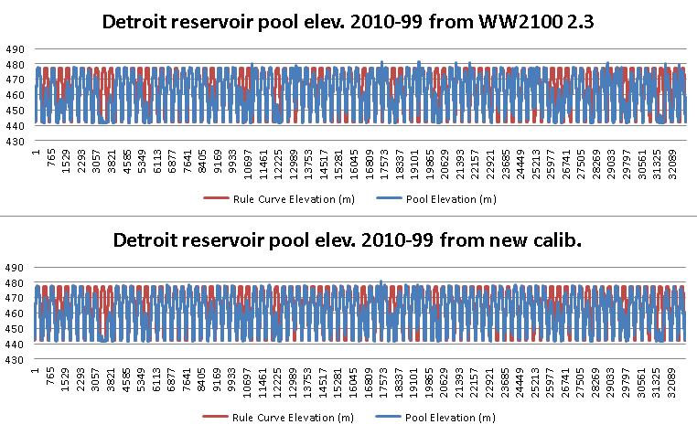

Figure . Detroit reservoir pool elevations, Ref scenario 2010-99

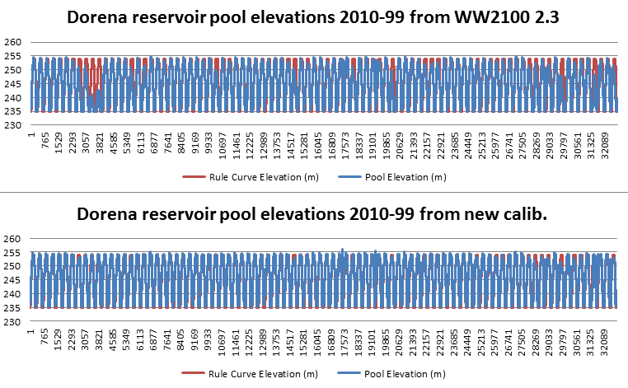

Figure . Dorena reservoir pool elevations, Ref scenario 2010-99

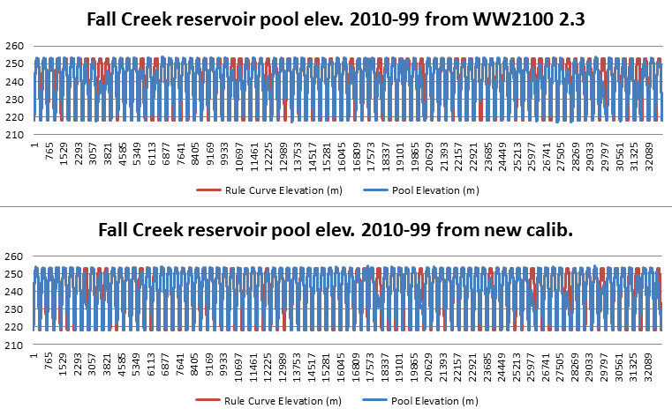

Figure . Fall Creek reservoir pool elevations, Ref scenario 2010-99.

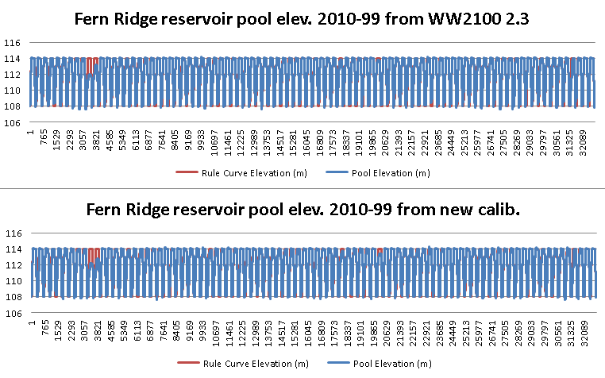

Figure . Fern Ridge reservoir pool elevations, Ref scenario 2010-99.

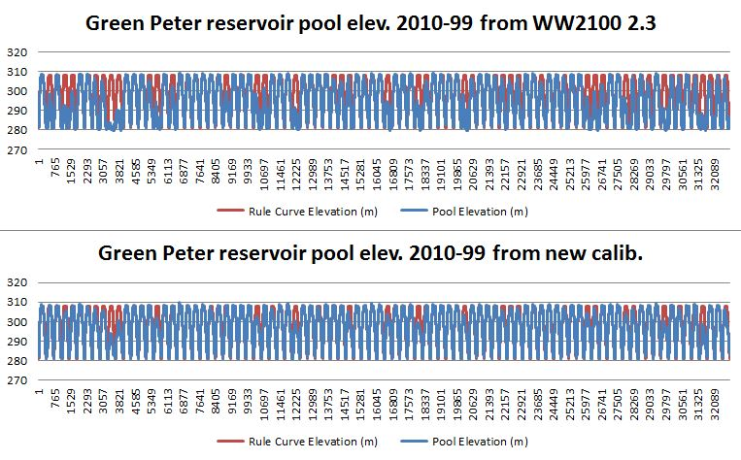

Figure . Green Peter reservoir pool elevations, Ref scenario 2010-99.

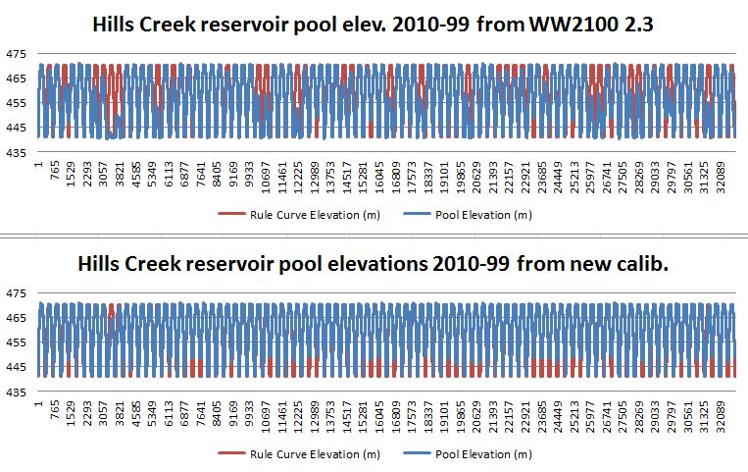

Figure . Hills Creek reservoir pool elevations, Ref scenario 2010-99.

# Acknowledgments

John Dalrymple at Oregon Freshwater Simulations ran the PEST program and handled the data for the 2016 calibration work. Eric Watson at Portland State University was very helpful when we were learning how the 2015 calibration was done. Sarah Lewis at Oregon State University provided much cheerful assistance with the high Cascades groundwater issue.

# References

Abebe NA, Ogden FL, Pradhan NR (2010). Sensitivity and uncertainty analysis of the conceptual HBV rainfall-runoff model: Implications for parameter estimation. Journal of Hydrology 389: 301-310.

Aghakouchak A, Habib E (2010). Application of a Conceptual Hydrologic Model in Teaching Hydrologic Processes. Int. J. Engng Ed. 26(4): 963-973.

Inouye AM (2015). Development of a Hydrologic Model to Explore Impacts of Climate Change on Water Resources in the Big Wood Basin, Idaho. M.S. thesis, Oregon State University.

Seibert J (1997). Estimation of Parameter Uncertainty in the HBV Model. Nordic Hydrology, 28 (4/5): 247-262.

Steele-Dunne S, Lynch P, McGrath R, Semmler T, Wang S, Hanafin J, Nolan P (2008). The impacts of climate change on hydrology in Ireland. Journal of Hydrology 356: 28-45.